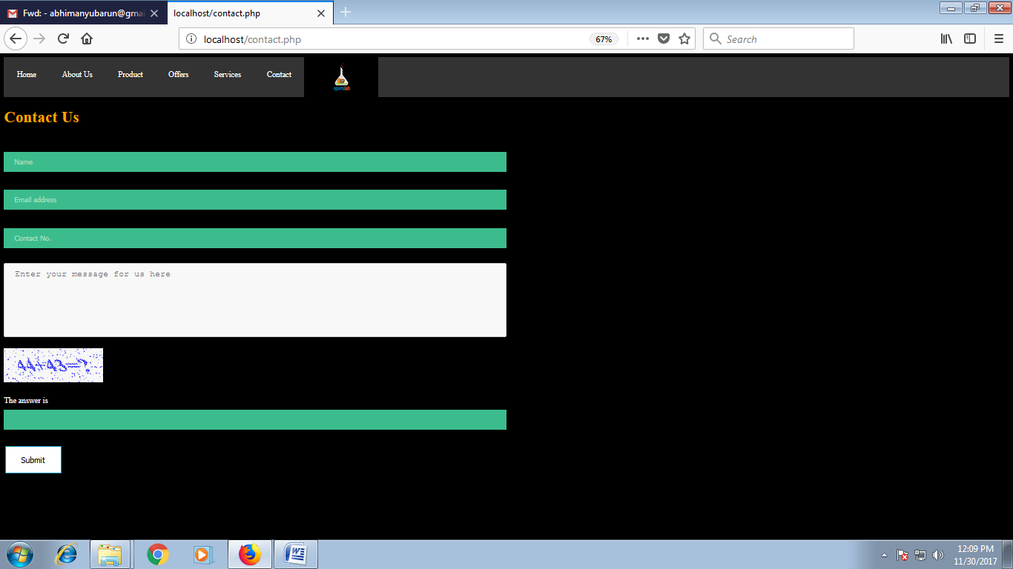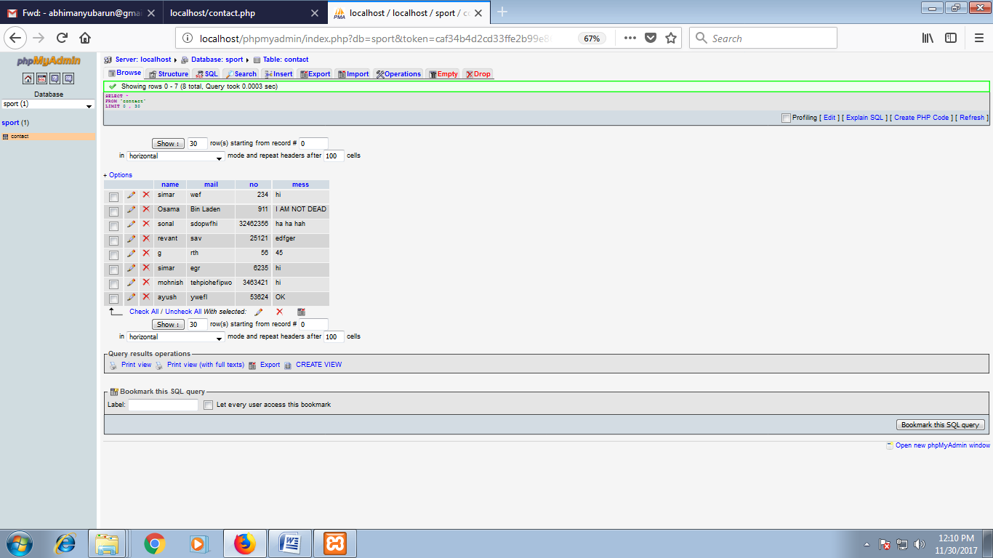

<html>

<head></head>

<style>

ul {

list-style-type: none;

margin: 0;

padding: 0;

overflow: hidden;

background-color: #333;

}

li {

float: left;

}

li a {

display: block;

color: white;

text-align: center;

padding: 24px 26px;

text-decoration: none;

}

li a:hover {

background-color: RED;

}

input[type=text] {

width: 50%;

padding: 12px 20px;

margin: 8px 0;

box-sizing: border-box;

border: none;

background-color: #3CBC8D;

color: white;

}

textarea {

width: 50%;

height: 150px;

padding: 12px 20px;

box-sizing: border-box;

border: 2px solid #ccc;

border-radius: 4px;

background-color: #f8f8f8;

font-size: 16px;

resize: none;

}

.button {

background-color: #4CAF50;

border: none;

color: orange;

padding: 16px 32px;

text-align: center;

text-decoration: none;

display: inline-block;

font-size: 16px;

margin: 4px 2px;

}

.button1 {

background-color: white;

color: black;

border: 2px solid #008CBA;

}

.button1:hover {

background-color: #008CBA;

color: white;

}

</style>

</head>

<script>

function f(){

var i = document.f1.txt5.value;

if(i==87)

{

alert("WELCOME"+f1.txt1.value+".We have recieved your message. YOUR REDEEM CODE IS 00001");

}

else

{

alert("YOU ARE ALIEN OR PATHETIC IN MATHS");

}

}

</script>

<body bgcolor="black">

<ul>

<img src="1.gif" width="150" height="80">

<li><a class="active" a href="main.html">Home</a></li>

<li><a href="1.html">About Us</a></li>

<li><a href="products.html">Product</a></li>

<li><a href="offers.html">Offers</a></li>

<li><a href="service.html">Services</a></li>

<li><a href="contact.html">Contact</a></li>

</ul>

<h1> <font color="orange">Contact Us</font></h1>

<br>

<form name="f1" method="post" action="<?php echo $_SERVER['PHP_SELF'];?>">

<input type="text" name="txt1" placeholder="Name">

<br><br>

<input type="text" name="txt2" placeholder="Email address">

<br><br>

<input type="text" name="txt3" placeholder="Contact No.">

<br><br>

<textarea rows="4" cols="50" name="txt4" placeholder="Enter your message for us here" ></textarea>

<br><br>

<img src="11.gif">'

<br><br>

<font color ="white">The answer is </font>

<br>

<input type="text" name="txt5">

<br>

<br>

<button class="button button1" name="sbt" OnClick=f()>Submit</button>

<?php

function add()

{

$servername = "localhost";

$username = "root";

$password = "";

$dbname = "sport";

$conn = new mysqli($servername, $username, $password, $dbname);

if ($conn->connect_error) {

die("Connection failed: " . $conn->connect_error);

}

$a=$_POST["txt1"];

$b=$_POST["txt2"];

$c=$_POST["txt3"];

$d=$_POST["txt4"];

$sql="INSERT INTO contact (name, mail, no,mess) VALUES('$a','$b',$c,'$d')";

if ($conn->query($sql)===TRUE)

{

echo "<font color=red>"."we have recieved your message,thank you for your review"."</font>";

}

$conn->close();

}

if(isset($_POST['sbt']))

{

add();

}

?>

</body>

</html>